Case Study | MG-1P Spraying for Manchurian Catalpa
Manchurian catalpa has high ecological and economic value. It is mainly distributed in the Yellow River and Yangtze River regions of China, as well as the northern provinces of Zhejiang and Anhui. Manchurian catalpa grows fast and are known for having elongated trunks and beautiful blossoms.
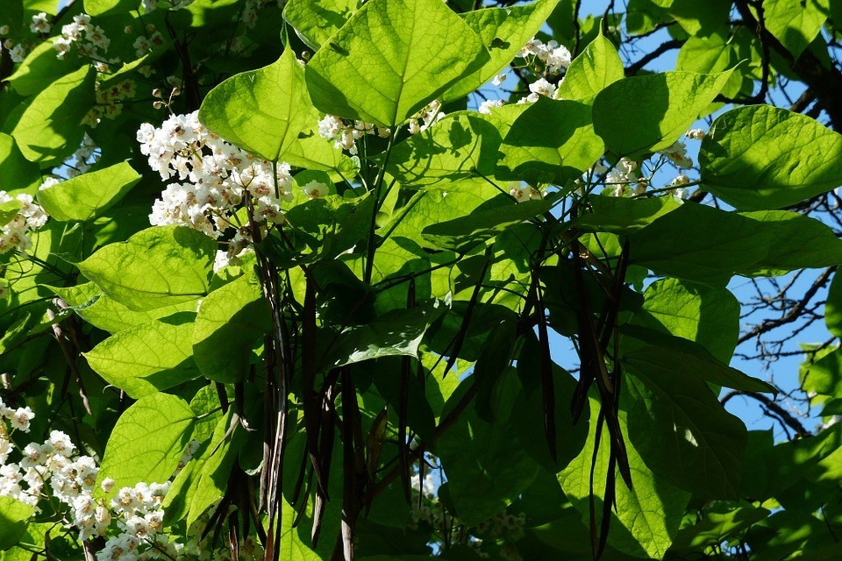
Common pests threatening Manchurian catalpa include Plautia, Basiprionota bisignata Boheman, nun moths, Edessena gentiusalis Walkers, hawk moths, Dictyoploca japonica Butler, Omphisa plagialis wileman, and Cicadella viridis. Common diseases are anthracnose and root-knot nematode. To prevent pests and diseases, the Timely Rain Aerial Plant Protection Specialized Cooperative in Hubei Province’s Shishou City used DJI’s MG series plant protection drones this past May to carry out spraying operations over an area of 500 mu.

1.
Team Introduction

The Timely Rain Aerial Plant Protection Specialized Cooperative in Shishou City offers drone plant protection services for large farming cooperatives and households, with the principle of "quality service, efficient operation, low price, and sincere cooperation." Drones owned by Timely Rain have increased from three DJI MG-1s to 15 plant protection drones (models include MG-1, MG-1S, and MG-1P) operated by 20 professional drone pilots.
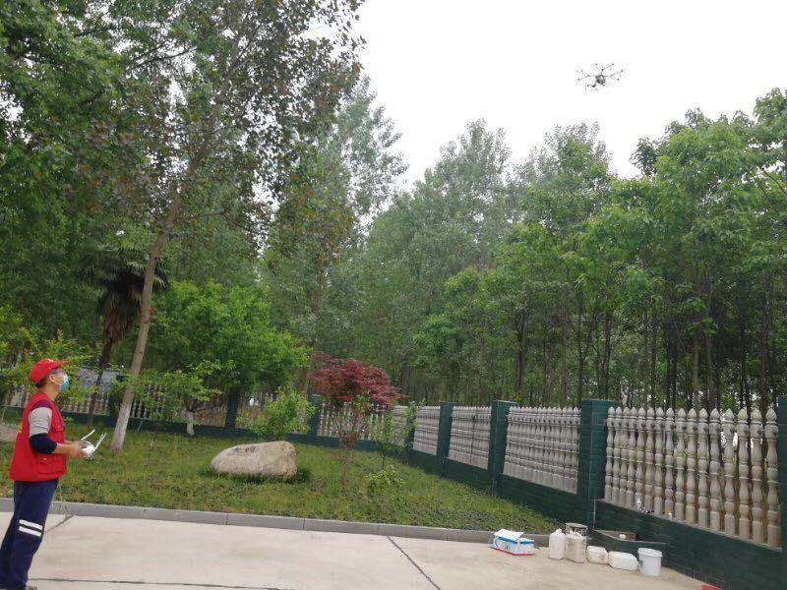
The cooperative can operate up to 6,000 mu* per day and has so far sprayed 130,000 mu of crops and plants, including reeds, wheat, soybeans, paddy, lotus root, corn, poplar, and more. Highly acclaimed by customers, their operations extend from local towns to surrounding counties, cities, and provinces.
2.
Environment Information

Operation Date | May 01, 2018 | Location | Shishou City, Hubei Province in Central China
Land Type | Plain | Environment | Safe surroundings, with some obstacles around the field

The Manchurian catalpa pest control operation, in this case, covers 500 mu.
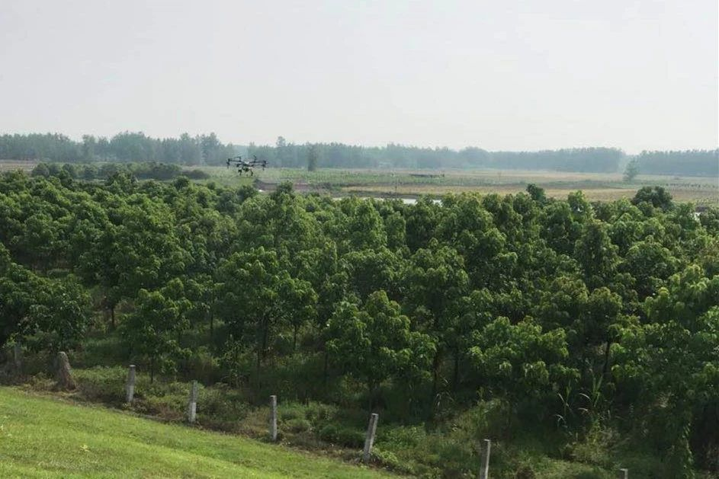
3.
Operational Parameters

Flight Mode | Manual | Flight Speed | 3 m/s
Flight Altitude | 3 m | Route Spacing | 4 m
Volume per Mu | 2L | Nozzle Type | XR110001 VS

4.
Herbicide Information ^{[1]}

Herbicide Name | Type | Concentration of Active Ingredient | Amount per Mu
Prochloraz + Epoxiconazole | EW | 45%  Prochloraz + 12.5% Epoxiconazole | 140 g
Lv Zhi Yi | Aqueous solution agent | 10% Amino acid + 6 essential trace elements | 100 g
Liang Tai | Suspending agent | 6% Avichlorobenzyl | 80 g

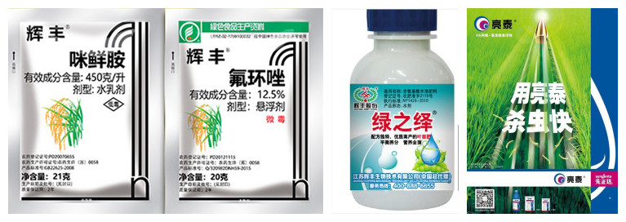
Because the trees in this case were around 7-8 years old and had lush leaves, the amount of herbicide per acre and water used in this operation is above average.

5.
Conclusion

The operation was quite effective as pests and diseases were controlled, the difficulty of operation over tall crops resolved, and toxicity incidents avoided. Plant protection via drone has proven to be an efficient method for Manchurian catalpa and has earned the approval and acclaim of customers.

Annotation:

*mu: Chinese area unit, 1 mu=1/15 hectares.

